Database Systems (Assignment) Lab 5

Name = Poorab Gangwani

Class = 4B1

Roll-Number = CS191092

Task 1

1. Count the number of employees in each department. Also, display the minimum salary of each department.

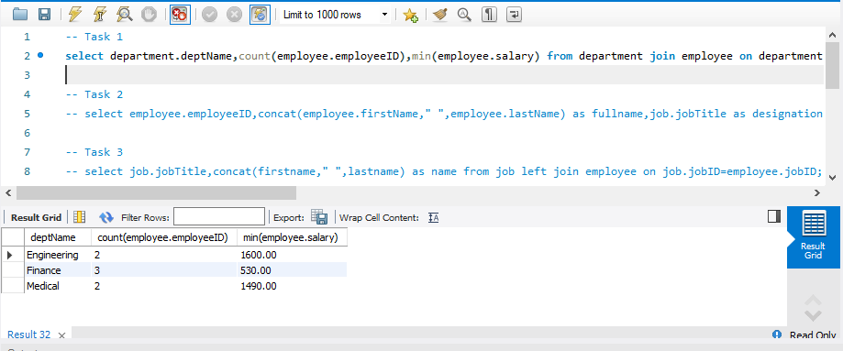

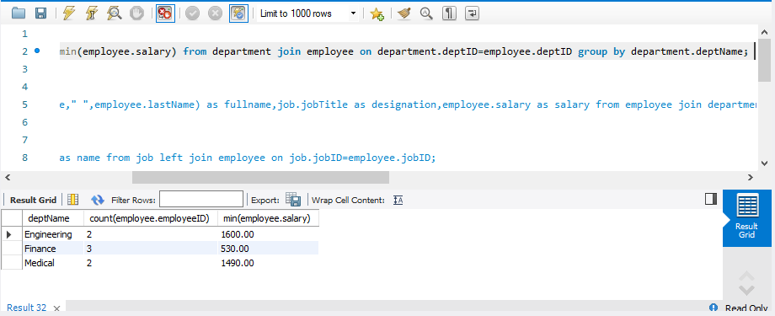

Task 2:

1. Display the id, full name, designation, and salary of the highest paid employee

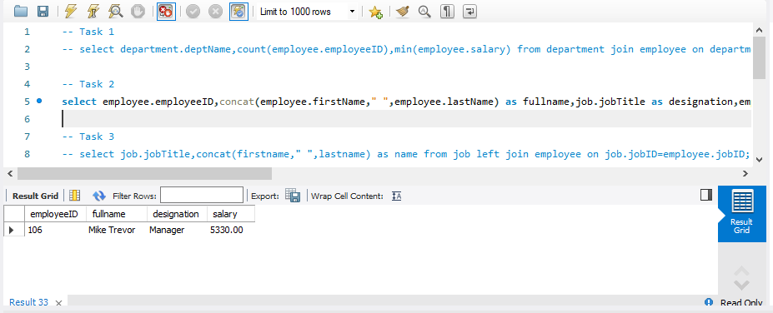

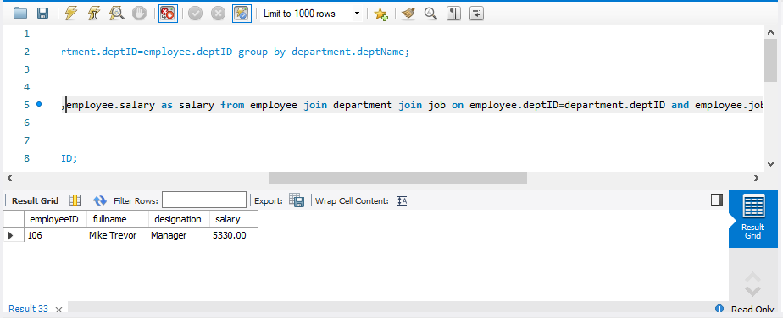

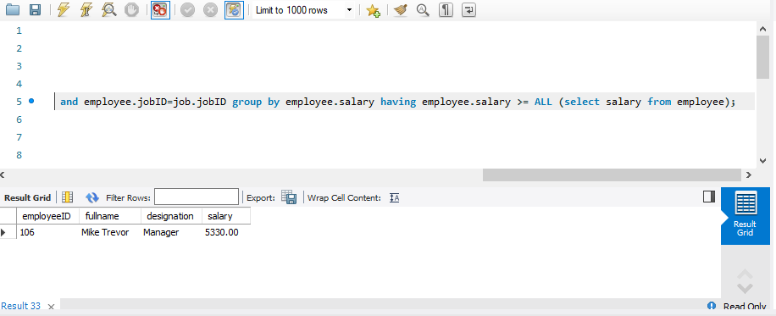

Task 3:

1. Display the names of all the designations along with the employees assigned to that designation (irrespective of whether the designation has been assigned to someone or not).

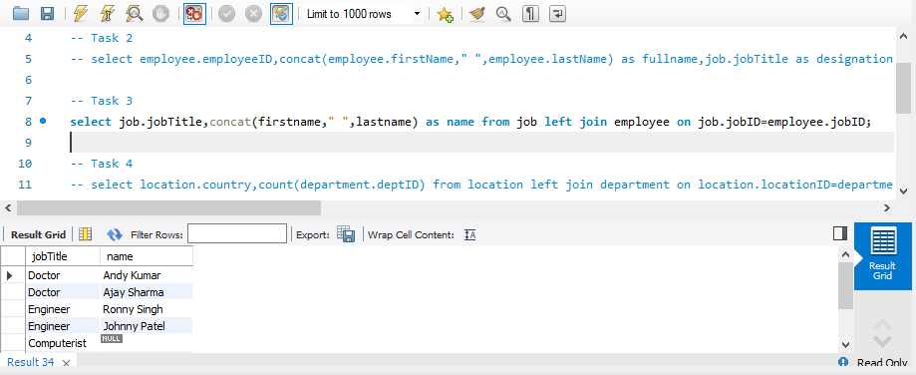

Task 4

1. List all the countries with more than one department. Also, give the total number of departments in that country.

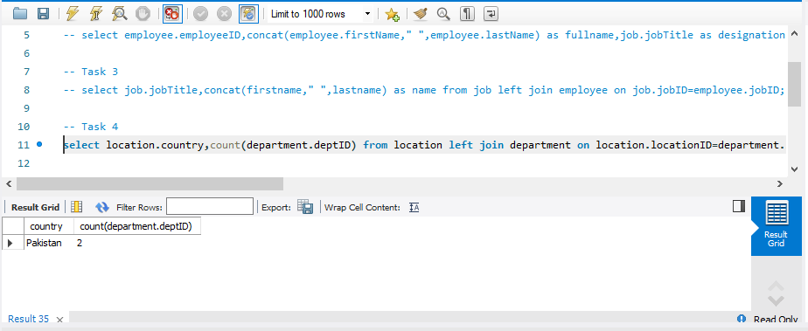

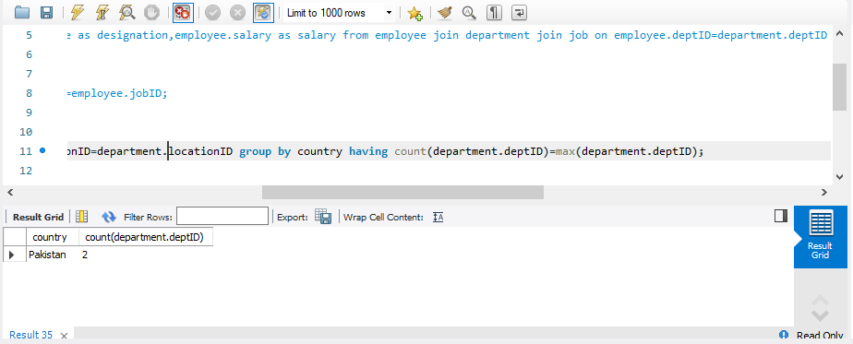

Task 5:

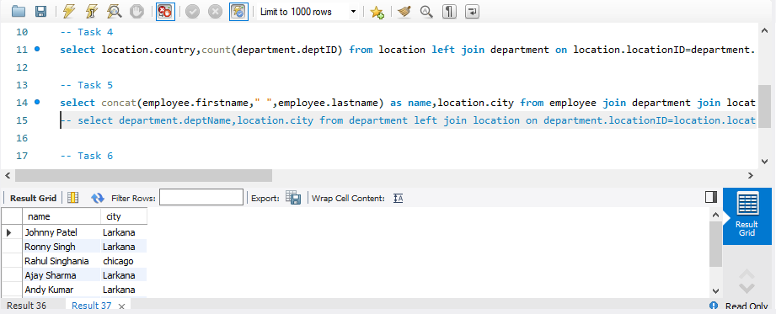

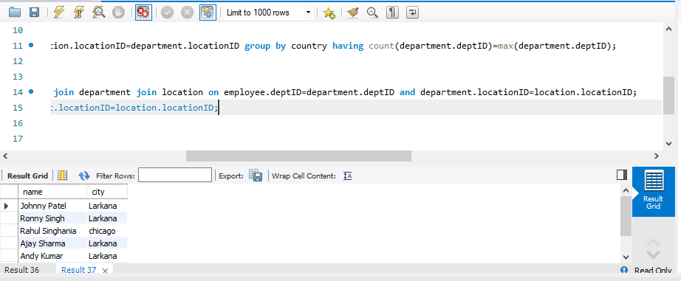

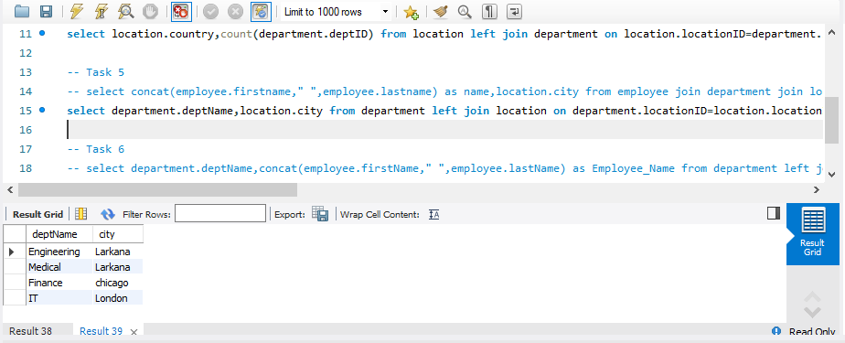

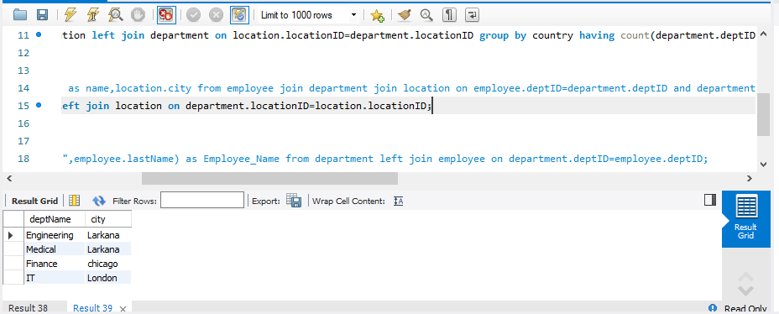

Task 6:

1. List all the departments along with their employees’ names (irrespective of whether any of the values is NULL)

